**COLONIAL NEWS**

Health Committee Newsletter January 2025

Welcome to the Albert Gallatin School District Health Committee’s monthly newsletter. Each month this publication will provide our district with health and fitness information. Our goal is for our students, families, and staff to use this information to make healthy decisions and to live a healthy active lifestyle.

**Start Small This Year**

Happy New Year! Who doesn’t love the idea of turning a new page in January? It can feel like anything is possible. If you’re all about getting healthier this year, you’re not alone — research shows that 79% of New Year’s resolutions are about health.  
  
But while motivation can be high on January 1, one study found that about half of all resolution-makers lose momentum as the month goes by. One way to make it easier to stick to your goals? Think small. A few tiny tweaks can have a big impact on your overall health — and feel much more doable.  
  
Here are 4 small ways to kickstart the new year — and make every day a little healthier.

1. **Start your day with water.** Do you dream of caffeine as soon as you open your eyes in the morning? Have a glass of water while your coffee or tea brews. Drink another glass before each meal to stay hydrated throughout the day.
2. **Turn down the heat.** A hot shower or bath in the wintertime may seem like just the thing on a chilly morning, but it can dry out your skin in no time. Instead, set a water temperature that feels warm and comfortable, but not hot.
3. **Take a stand.** Sitting for hours — whether at your desk or on the couch — has been shown to raise the risk for a host of serious health problems, including obesity, diabetes, cancer, depression, and even early death. If you find yourself sitting a lot, set a timer for every hour and make it a point to stand up and walk around for at least 2 minutes. Take a lap around the office, grab some water, or just give yourself a nice stretch.
4. **Think like a chef.** It’s easy to let good food hygiene go when you’re in a hurry to get dinner on the table. But no one wants a few careless missteps to bring on a case of food poisoning or trigger a food allergy for someone. This year resolve to clean up your cooking habits. Wash your hands, rinse fruits and veggies well, and use separate cutting boards and knives for produce and raw meat. They’re all small ways to stay safe.

(Adapted from Source: ACSHIC)

**Make the Most of Winter**

Winter is one-fourth of our lives. December weeks were filled with holiday cheer, sparkling decorations, and the anticipation of some long-awaited time with friends and family. But as winter wanes on, it can be hard to muster up excitement for three more months of cold and darkness. An average of 41% of Americans say their mood droops in the colder months.  
  
Maybe winter is your favorite season but if it is not you can tolerate it more by adapting the activities you love for colder weather, or leaning into winter’s uniqueness and enjoying it before it slips away. Here are some suggestions to help make the most of the next few months.  
  
**Notice the little things.** Be mindful of your surroundings — the crunch of leaves or snow as you walk, the crackle of a warm fire, the bright color of a red cardinal against the white snow.  
  
**Create cozy rituals.** Try cooking or baking new comforting, seasonal recipes, amp up your usual nightly reading ritual with a warm cup of tea or hot chocolate.   
  
**Move (even when it’s hard).** One of the luxuries of summer days is being able to take a morning and/or evening walk. Instead of giving up on them entirely when the days are short, bundle up during lunch and take a 30-minute walk outside.

(Adapted from Source: ACSHIC)

Prepared by Lisa Sumey, Central Office Secretary

**Recipe of the Month**

Slow Cooker Pot Roast

Ingredients:

* 1 cup warm water
* 1 tablespoon beef base
* 1/2 pound sliced fresh mushrooms
* 1 large onion, coarsely chopped
* 3 garlic cloves, minced
* 1 boneless beef chuck roast (3 pounds)
* 1/2 teaspoon pepper
* 1 tablespoon Worcestershire sauce
* 1/4 cup butter, cubed
* 1/3 cup all-purpose flour
* 1/4 teaspoon salt

Directions:

1. In a 5- or 6-qt. slow cooker, whisk water and beef base; add mushrooms, onion and garlic. Sprinkle roast with pepper; transfer to slow cooker. Drizzle with Worcestershire sauce. Cook roast, covered, on low 6-8 hours or until meat is tender.
2. Remove roast to a serving platter, tent with foil. Strain cooking juices, reserving vegetables. Skim fat from cooking juices. In a large saucepan, melt butter over medium heat. Stir in flour and salt until smooth; gradually whisk in cooking juices. Bring to a boil, stirring constantly; cook and stir 1-2 minutes or until thickened. Stir in cooked vegetables.
3. Serve with roast.

Source: ACSHIC

   
  
  
  
   
  
 

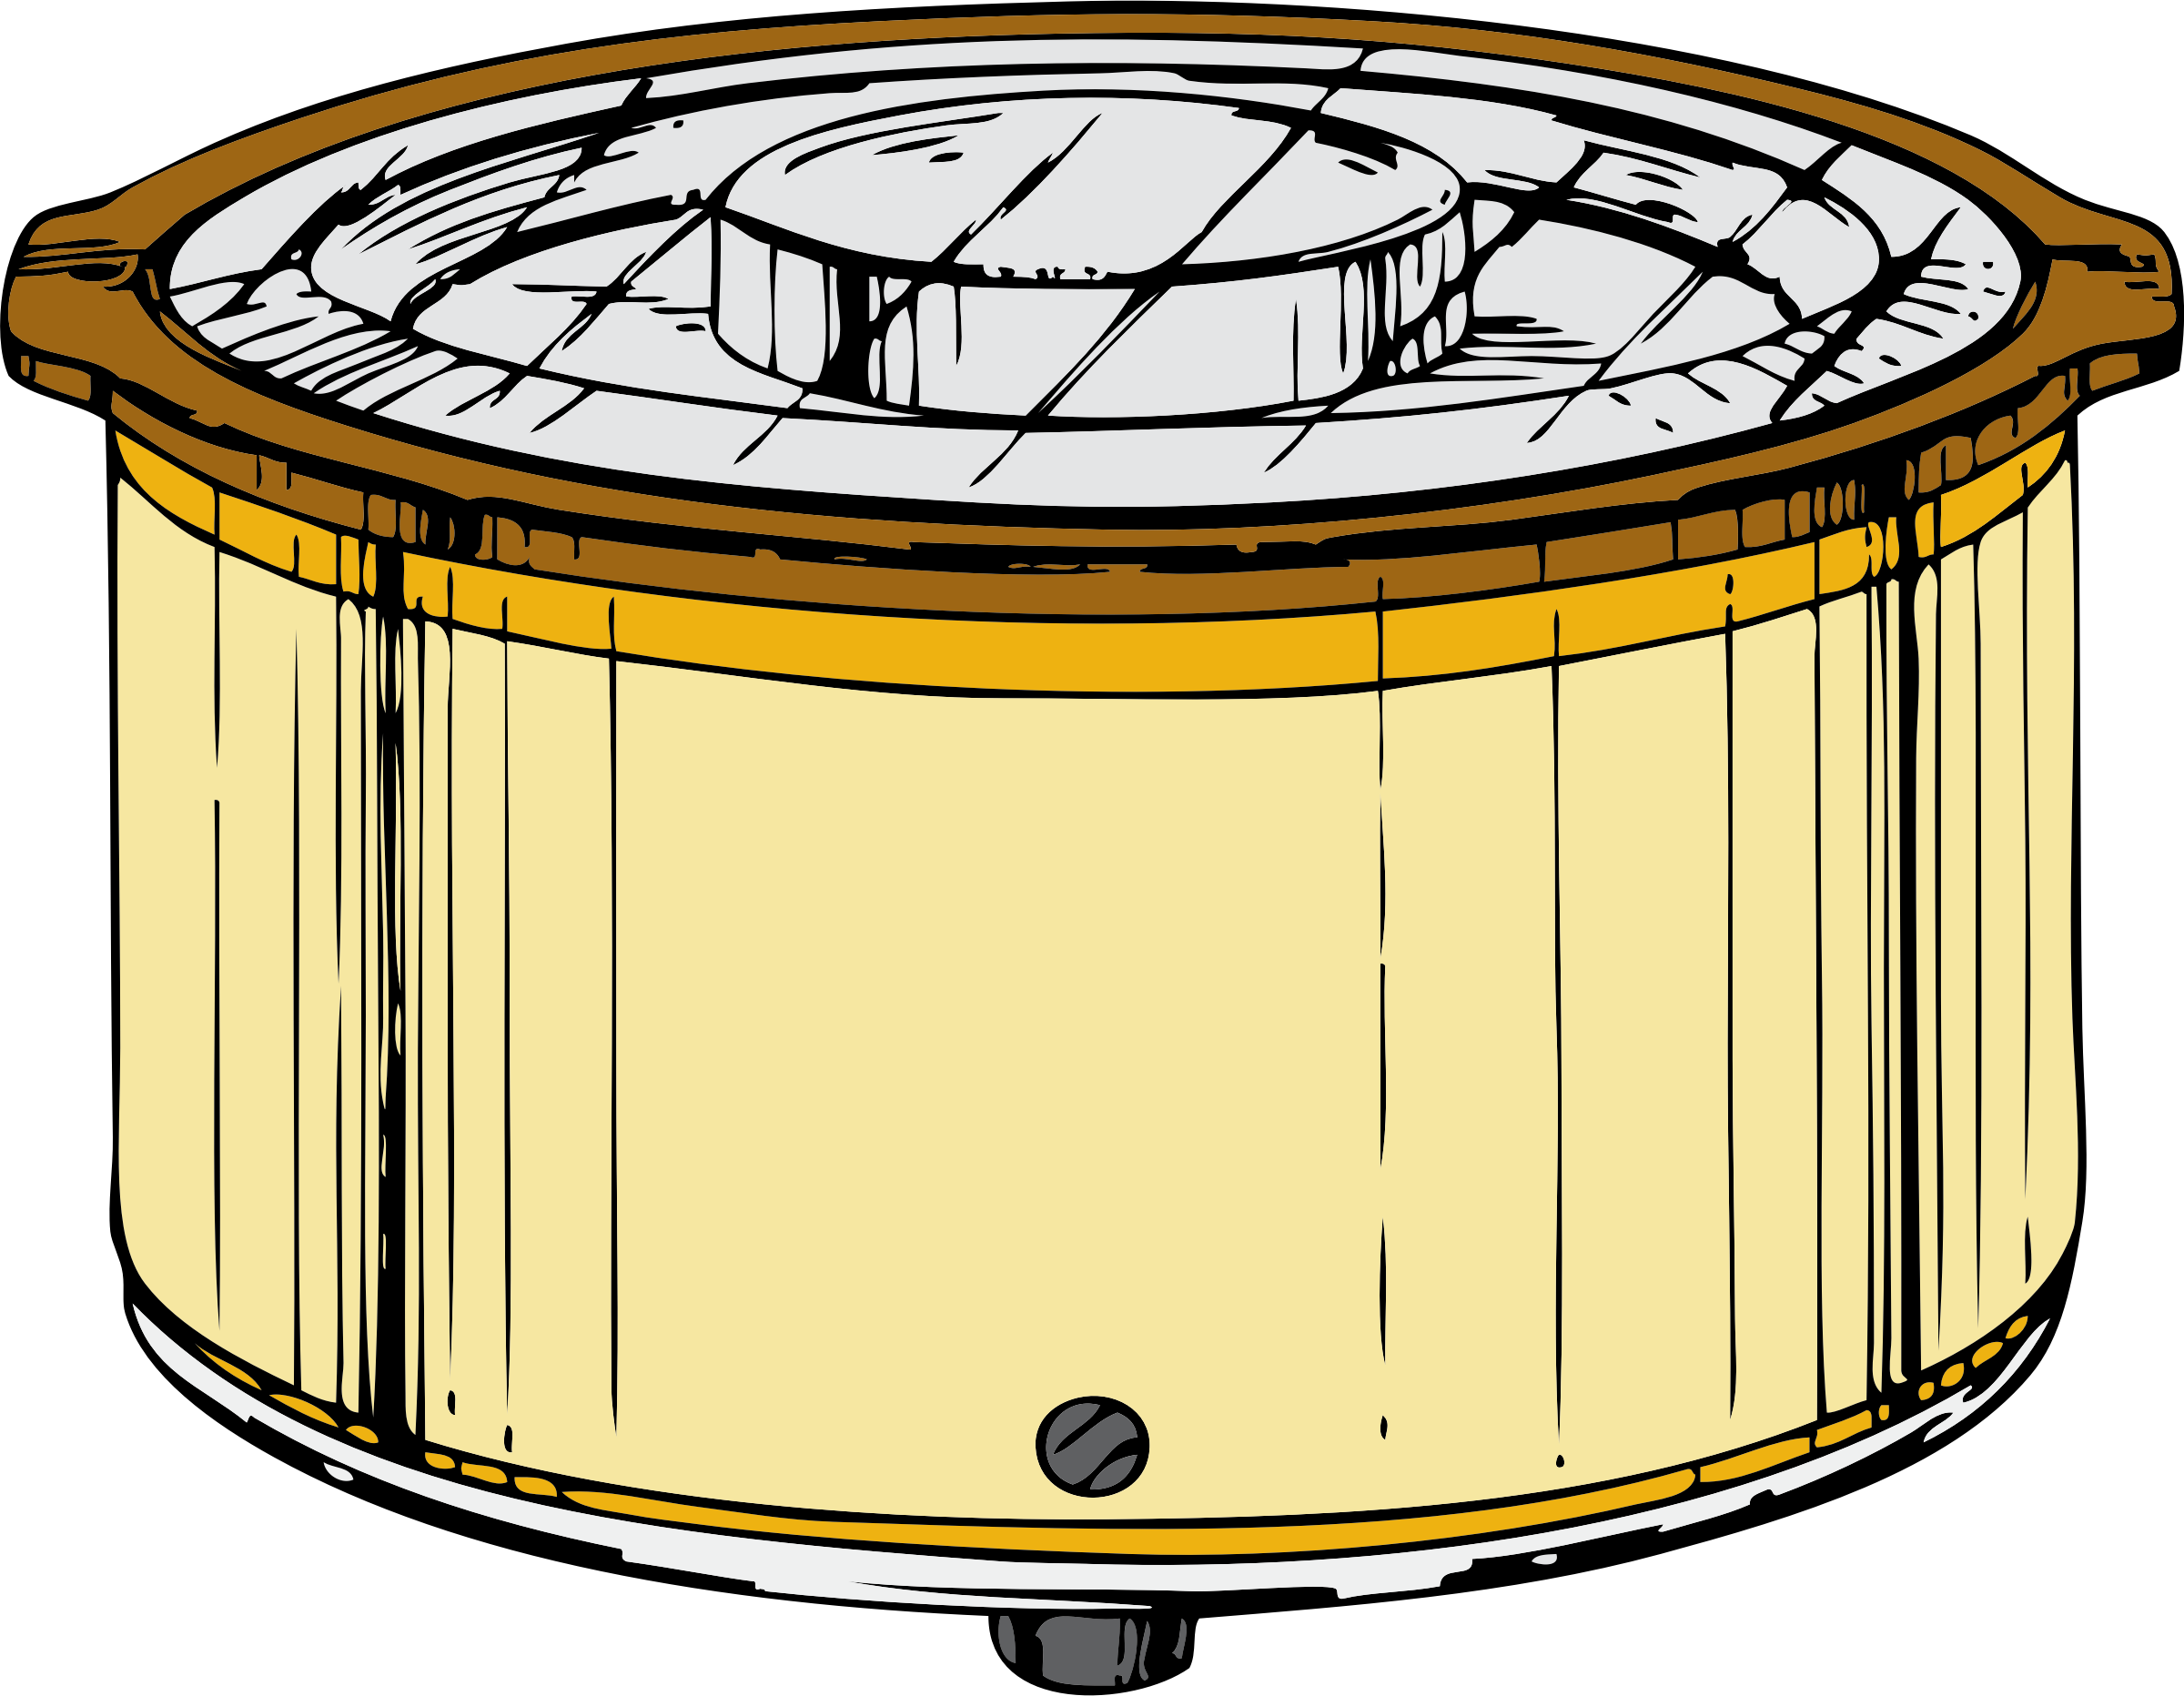

**National Food holidays**

**Freshen up your menu and add more fun to your meals by celebrating this months’ National Food Holidays.**

**Apricot Day – January 9**

***We’ve been enjoying this sweetness for over 4000 years!*** Often confused with their sister fruit peaches, Apricots date back to as early as 2000 BC when they were first cultivated in China and Central Asia. They were introduced in Greece by Alexander the Great and English and Spanish settlers brought them to the United States.

**Gluten-Free Day – January 13**

***Gluten-free has never meant taste-free!*** With the number of Americans with gluten issues continuing to rise, looking for gluten-free options has become even more important. Fortunately, there are millions of gluten-free products now available that taste as great as their gluten counterparts!

**Granola Bar Day – January 21**

***It’s time to celebrate this wholesome, handheld, healthy snack!*** The granola bar is a staple at our breakfast tables and rescues us on hectic workdays.

Source: goldstarfoods.com